Variant Management Sample
Smoke Test
(Dictionary for Product Variability)



Aras Corporation
© 2002 Aras Corporation. All rights reserved

Aras Corporation
300 Brickstone Square
Suite 700
Andover, MA 01810

Phone: 978-794-7643
Fax: 978-794-9826

E-mail: info@aras-corp.com
Website: http://www.aras-corp.com

Notice of Rights
All rights reserved. Aras Corporation (Aras) owns this document. No part of this document may be reproduced or transmitted in any form by any means, electronic, mechanical, photocopying, recording, or otherwise, without the prior written permission of Innovator and other Aras product names and logos are trademarks of Aras Corporation.

Notice of Liability
The information contained in this document is distributed on an “As Is” basis, without warranty. While every precaution has been taken in the preparation of this document, Aras shall have no liability to any person or entity with respect to any loss or damage caused or alleged to be caused directly or indirectly by the information contained in this document or by the software or hardware products described in it.

NAME | Description of update | Date Updated
Olena Zaporozhets | Initial Creation to Aras Innovator 12.0 - Variant Management Sample Application.pdf | 03/02/2020
Olena Zaporozhets | Updating of documentation | 11/09/2020
Olena Zaporozhets | Updating of documentation according to Ui of 12SP12 | 01/12/2021

Table of Contents

1 Send Us Your Comments 4
2 Overview 5
3 Prerequisites 6
3.1 Server Machine Setup 6
3.2 Client Machine Setup 6
3.3 Make sure notifications about every scripts error enabled in your browser 6
3.4 Test Setup 6
4 Functional Tests 8
4.1 Features 8
4.2 Options 9

Send Us Your Comments
Aras Corporation welcomes your comments and suggestions on the quality and usefulness of this document. Your input is an important part of the information used for future revisions.
- Did you find any errors?
- Is the information clearly presented?
- Do you need more information? If so, where and what level of detail?
- Are the examples correct? Do you need more examples?
- What features did you like most?

If you find any errors or have any other suggestions for improvement, indicate the document title, and the chapter, section, and page number (if available).

You can send comments to us in the following ways:
- Email:
Support@aras.com
Subject: Aras Innovator Documentation
Or,
- Postal service:
Aras Corporation
300 Brickstone Square
Suite 700
Andover, MA 01810
Attention: Aras Innovator Documentation
Or,
- FAX:
978-794-9826
Attn: Aras Innovator Documentation

If you would like a reply, provide your name, email address, address, and telephone number.

If you have usage issues with the software, visit http://www.aras.com/support/

Overview
This Smoke Test document will go through and validate that the basic functionality of Variant Management Application.

Prerequisites
There are a few prerequisites that need to be done before the test plan can be executed.

Server Machine Setup
- Innovator needs to be set up (refer to the Innovator install guide)
- Vaults need to be set up and functional (refer to the Innovator install guide)
- Your database needs to be a FRESH database with all the correct patches applied to it
- You should have the previous version of Innovator installed on the system as well. (This helps catch installer errors.)

Client Machine Setup
- Clean up cache
  - Delete Browser temporary files
  - Delete assembly files
- If Browser Firefox delete Innovator XPI extension from list of Firefox Add-ons

Make sure notifications about every scripts error enabled in your browser

Test Setup
Purpose: | To prepare instance and data for further testing.
- Download VM build.
- Launch Aras Update.
  - Go to Local tab in the sidebar.
  - Click on “Add package reference”
  - Select the VM Sample Application installation package –> Click OK.
    - Confirm that VM Sample is displayed in the list of packages.
  - Click on Install
- Select the components you want to install
Aras Innovator Code Tree Updates
Aras Innovator Database Updates
Sample Data Actions
- Click Next
- Choose Detailed Logging -> Click Next
- Enter the required parameters for the target Aras Innovator instance
  - Click on Browse for Install Path field.
  - Select the path of the necessary instance to the Innovator folder.
- Expand Aras Innovator Database Updates.
  - Fill in Server URL, Database.
  - Username: root.
  - Password: innovator.
- Click on Install.
  - Confirm that VM sample successfully installed.
- When the package finishes installing, close Aras Update
- Log into Innovator as admin.
- In the main menu, select Actions > Load Variant Management Sample Data.
- When prompted, enter the file path of the Variant Management Sample Application package.
Example: If the Variant Management Sample Application package was downloaded and unzipped to C:\VMSample, enter C:\VMSample.
- Running the Load Variant Management Sample Data action will overwrite any variant sample data loaded by a previous execution. Click Ok in the warning prompt to continue loading.
- After the load completes, navigate to Variant Management in the TOC to confirm that instances of Features, Options, Breakdown Items, Variability Items, and Variable Components have been added.

Functional Tests

Features
Test # | VM-DfPV-001
Purpose: | To test the creation and deletion of Features
Test Setup | Pass Test Setup from 3.4
- Log into Innovator as admin

- Variant Management in Navigation panel
  - Go to Variant Management section in Navigation panel
    - Confirm that there are icons for Breakdown Items, Variability Items, Variable Components, Features and Options items
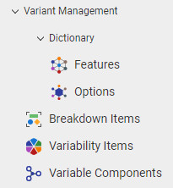
- Create Feature using Dictionary section
  - Go to Variant Management section in Navigation panel -> Dictionary -> Features
    - Confirm that the following menu appears
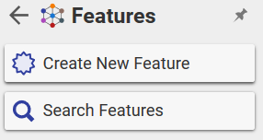
  - Click Create New Feature
    - Confirm that the following form appears
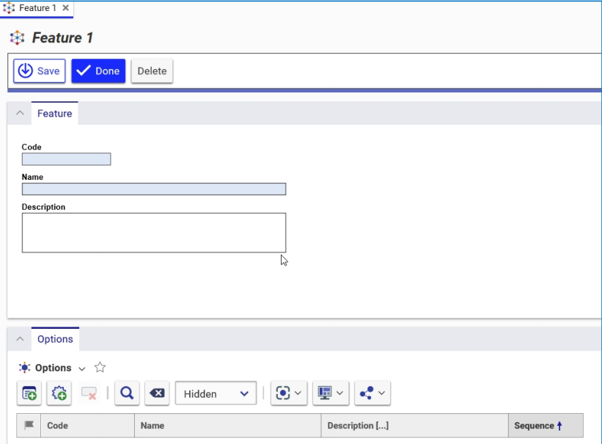

  - Enter the Feature Code and Name in the appropriate fields.
Code: F001_new
Name: TestF1
Description field: is optional
  - Click Done
    - Confirm that there is icon near keyed name of Feature
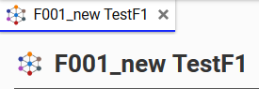
  - Close the Item

- Delete Feature:
  - Open Feature tab using Dictionary section
  - Click on Search in Features tab
  - Select F001_new TestF1 -> RMB -> More -> Delete -> Delete
    - Confirm that F001_new TestF1 was removed

Options
Test # | VM-DfPV-002
Purpose: | To test the creation and deletion the Options
Test Setup | Pass Test Setup from 3.4
- Log into innovator as admin

- Create Option using Dictionary section
  - Go to Variant Management section in Navigation panel -> Dictionary -> Options -> Click loupe
  - Click the New Option icon on the Options toolbar of the Search grid
  - Type
Code: 0121_new
Name: Medium
Description field: is optional
  - Click Done
    - Confirm that there is the icon near keyed name of Option
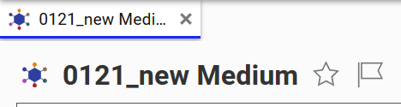
  - Close the Item

- Add Options to Features

  - Go to Variant Management section in Navigation panel -> Dictionary -> Features -> Search Features
  - Click in the Search grid to run a search for all Features
  - Select F015 Frame Material Feature -> Double-click the desired Feature -> Edit
    - Confirm that the Feature has Options relationship tab
    - Confirm that the Options listed on the Options tab are already related to the Feature
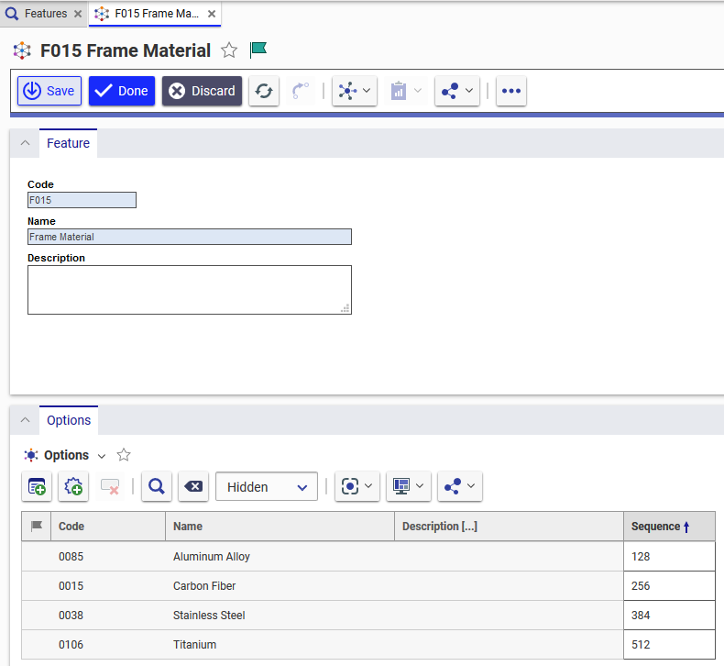

  - Go to Options tab
    - Confirm that there is icon near Options title
    - 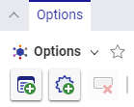
  - Click on Add Options :
    - Confirm that Search Dialog appears
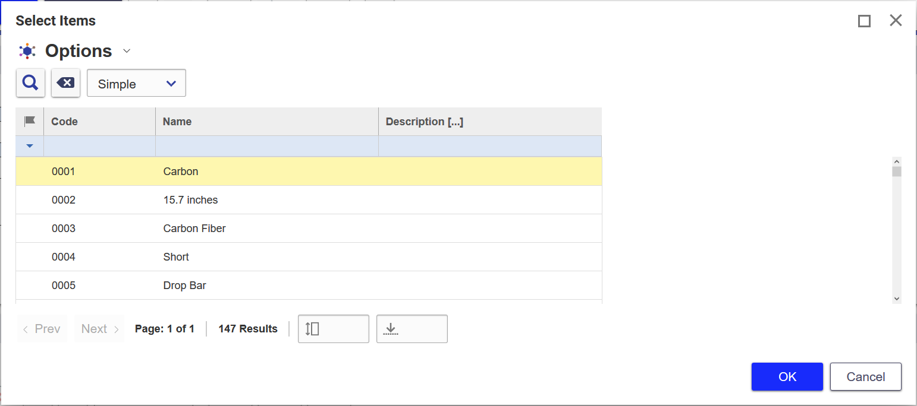
  - Run search -> Select option with 0121_new Code -> OK
    - Confirm that 0121_new is displayed
  - Click Save button for F015 Frame Material
  - Click on New Option :
    - Confirm that new row is displayed.
    - Type:
Code: 0122_new
Name: Medium_2
Description: New Option with name Medium_2
  - Click Save button for F015 Frame Material
    - Confirm that popup message appears in top right corner of the form
    - Confirm that there are 0121_new and 0122_new in Options tab.
  - Close F015 Frame Material Item

- Unpick Option
  - Click on Search in Features tab
  - Select and open F015 Frame Material -> Edit
  - Go to Options tab
  - Select 0121_new and 0122_new Options-> Click Delete Feature Option
  - Save item
    - Confirm that rows with 0121_new and 0122_new were removed
  - Click Done -> Close F015 Frame Material

